

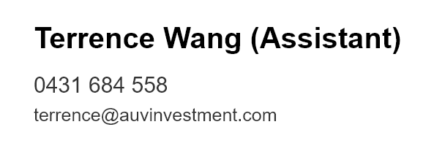**HOUSE FOR RENT**

3 Beds, 1 Bath, 1 Parking

31 Cushing Avenue，Bentleigh VIC 3204

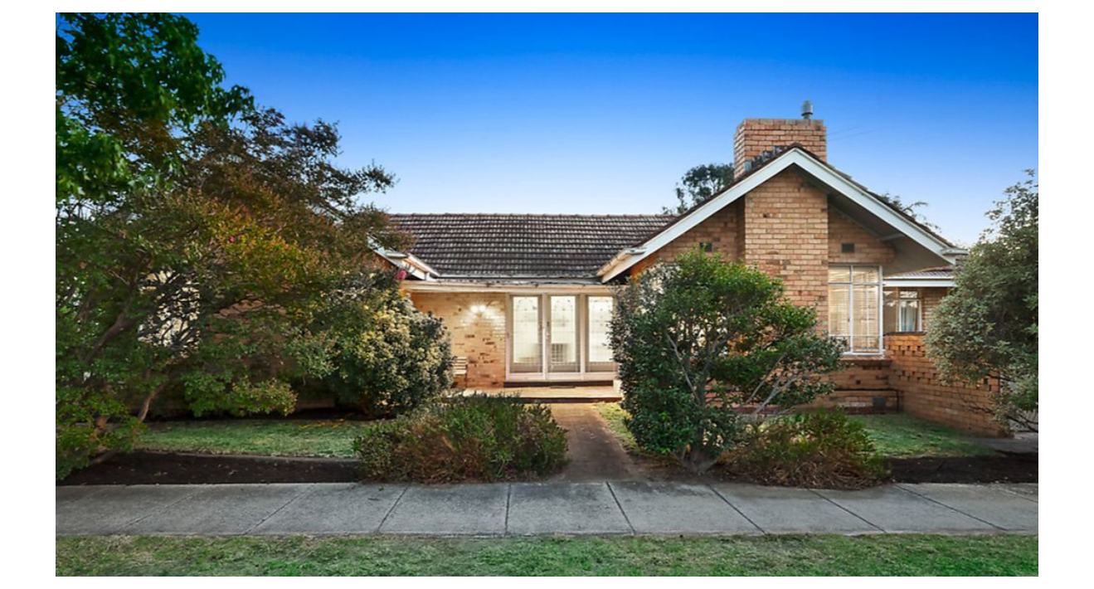

**Recreation**

Rec Xpress 24/7 Fitness Bentleigh

Re-Creation Health Club Brighton East

Coatesville Bowling Club

Caulfield Recreation Tennis Club

**Rent.**

$520/ Week

**Bond.**

$2,260

**Parks**

Allnutt Park

Chadoobie town

Bentleigh Hodgson Reserve

**Shops**

Chadstone Shopping Center

**Schools**

[McKinnon](http://www.mvps.vic.edu.au/) Secondary College

St Paul’s Primary School

McKinnon Primary School

**Transport**

Train – Bentleigh Station

Bus- Centre Road (701, 703,

979)

If you interested this property, please apply online by 